**SCHEMA-DIAGRAM**

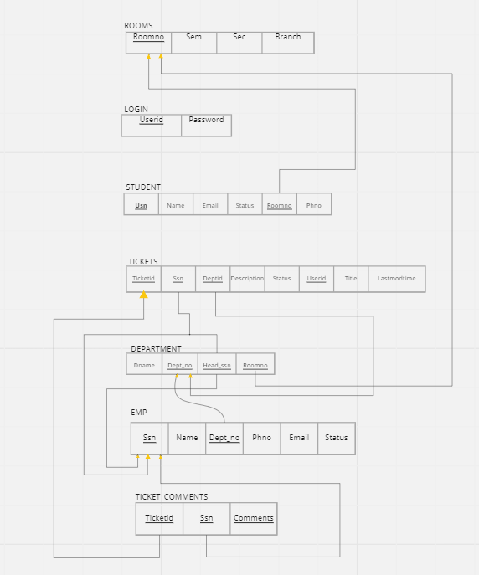

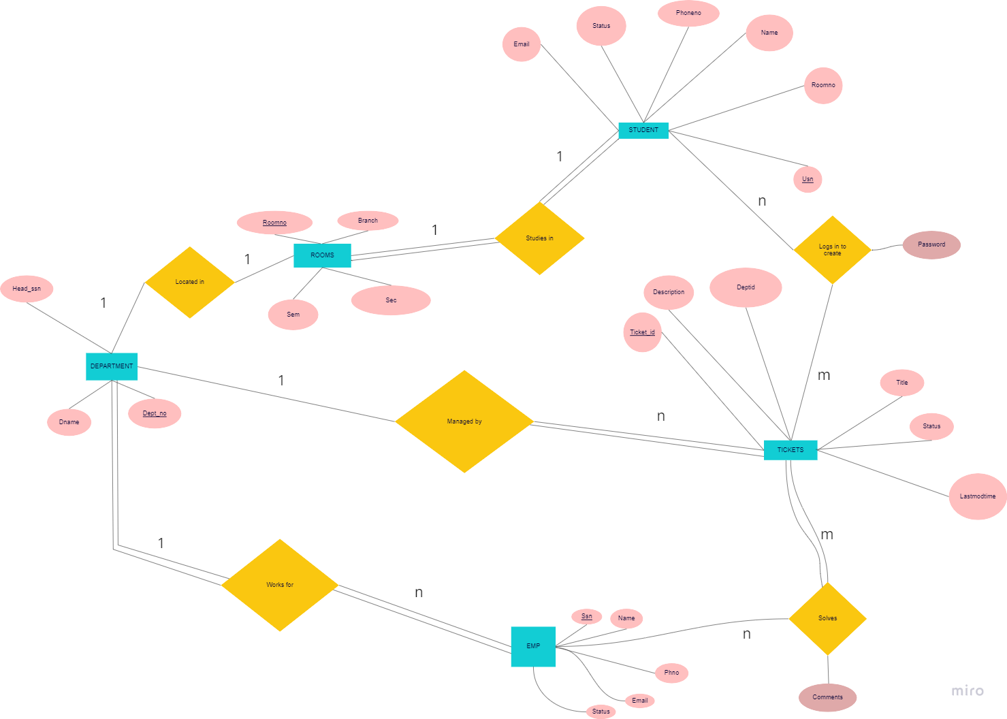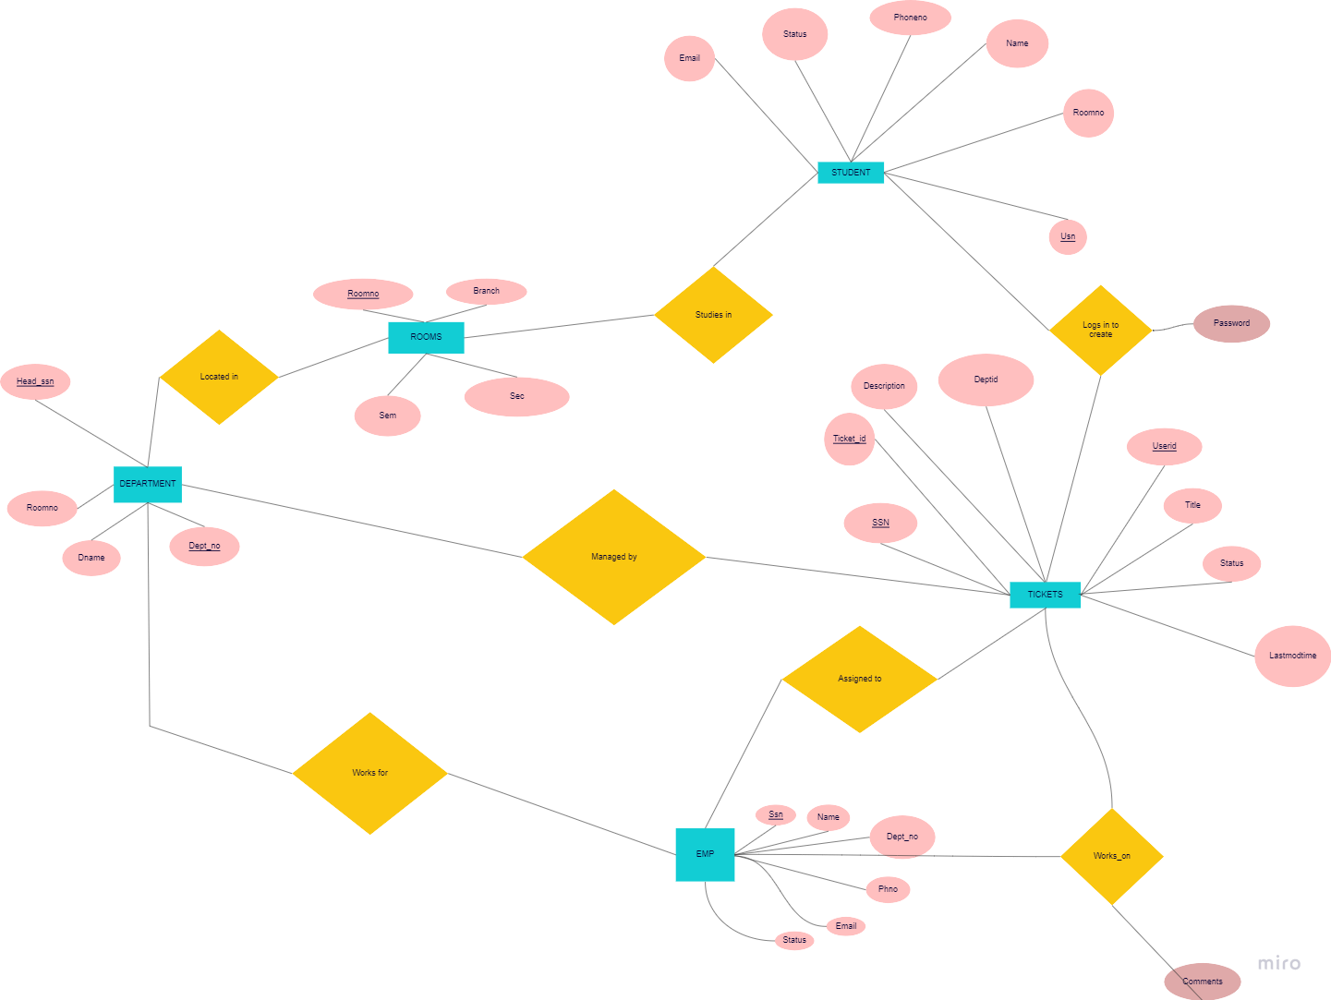

**ER-DIAGRAM**

**Objectives :**

**●** Inter-organization communication track

● Ticket raising and resolution

● Head-Student / Super-student communication track

● Ticket histories

● Management satisfaction tools

**NORMALIZATION :-**

Normalization is a database design technique which organizes tables in a manner that reduces redundancy and dependency of data. If a database design is not perfect, it may contain anomalies, which are like a bad dream for any database administrator. Managing a database with anomalies is next to impossible.

• **Update anomalies -** If data items are scattered and are not linked to each properly, then it could lead to strange situations. For example, when we try to update one data item having its copies scattered over several places, a few instances get updated properly while a few others are left with old values. Since instances leave the database in an inconsistent state.

• **Deletion anomalies** – It occurs when we try to delete a record, but parts of it was left undeleted because of unawareness, the data is also saved somewhere else.

• **Insert anomalies –** It occurs when we try to insert data in a record that does not exist at all.

**First Normal Form**

It states that the domain of an attribute must include only atomic values and the values of any attribute in a tuple must be single value from the domain of that attribute. 1NF only permits single atomic values.

All the above relations are in 1NF because all the attributes are atomic.

**Second Normal Form**

A relation schema is in 2NF if it is 1NF and every nonprime attribute A in R is fully functionally dependent on the primary key of R.

All the relations are already in 2NF because every non key attribute of the relation is fully functionally dependent on the primary key attribute.

**Third Normal Form**

A relation schema R is in 3NF if it satisfies 2NF and nonprime attribute of R is transitively dependent on the primary key.

